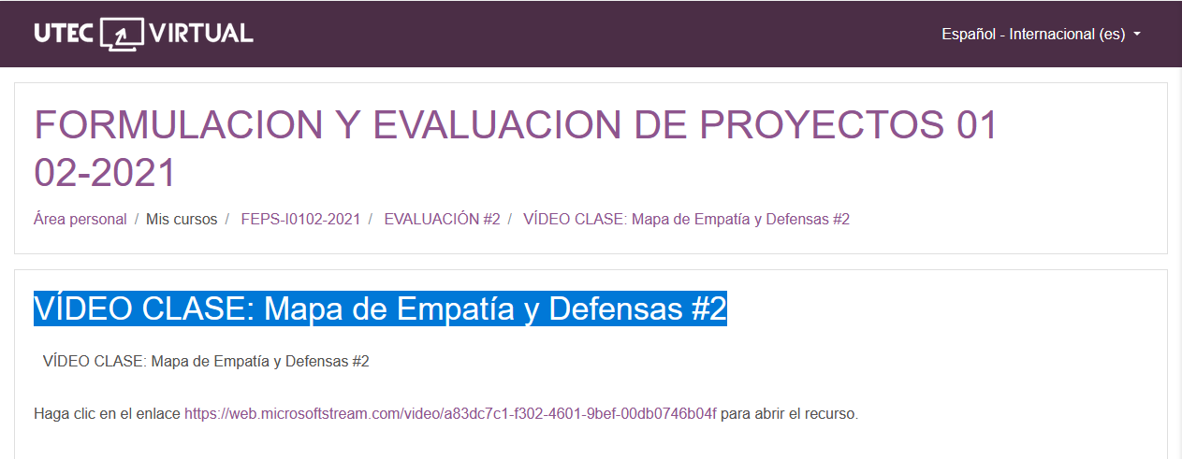

<https://web.microsoftstream.com/video/a83dc7c1-f302-4601-9bef-00db0746b04f>